Eliza Ellen (Smith) Dishong
March 29, 1863 – October 8, 1934

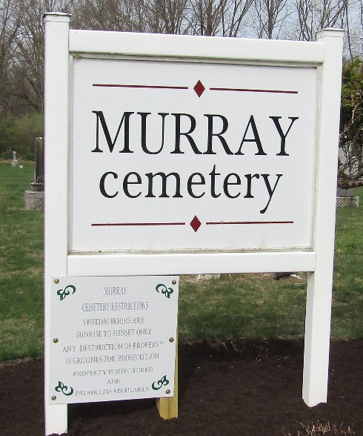

ELIZA DISHONG DIES SUDDENLY
Well Known Kingsland Lady Suffers Fatal Heart Attack

Mrs. Eliza Dishong, 71, widow of the late Elijah Dishong, died suddenly of a heart attack between 12 and 1 o'clock this afternoon in the yard at her home in Kingsland. Coroner William Thoma, who made an investigation, reported that death was due to a heart attack.
Mrs. Dishong lived along. She had stepped out of the house into the back yard at her home when she was stricken. Neighbors found the body and summoned the coroner.
She is survived by six children, Mrs. Edward Wedler, Kingsland; Mrs. Katie Kahn, Bluffton; Forrest Dishong, Fairmont, Minn.; Mrs. Martha Oker, Carthage; and Mrs. William Smith, Decatur. Three children and two sisters are deceased.
Mrs. Dishong was a member of the Kingsland M. E. Church.
Funeral services will be conducted at 2 o'clock Wednesday afternoon at the Kingsland Methodist Church with burial in the Murray Cemetery.

Unknown source
Handwritten date: October 8, 1934

**
Indiana, U.S., Death Certificates, 1899-2017
Name Mrs Eliza Smith Dishong
[Mrs Eliza Smith]
Gender Female
Race White
Marital Status Widowed
Age 71
Birth Date 29 Mar 1863
Birth Place Indiana
Death Date 8 Oct 1934
Death Place Kingsland, Wells, Indiana, USA
Death Registration Date 1934
Father Smith
Mother Martha Drumm
Spouse Elijah Dishong
Informant Mrs. O. E. Wedler; Kingsland, Indiana
Burial October 10, 1934; Murray Cemetery

