Elijah Jonah Dishong
1844 – April 19, 1907

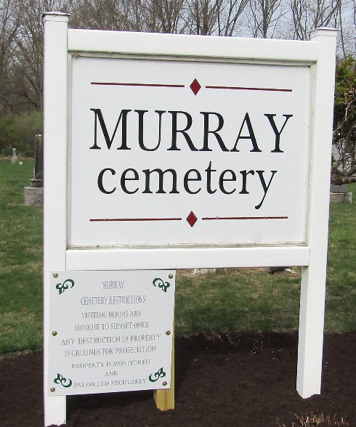

Elijah Dishong Dead

Elijah Dishong, aged about sixty, died this forenoon at his home near Kingsland. He had been sick for some time.
Unknown source
**
Elijah Dishong
in the Indiana, U.S., WPA Death Index, 1882-1920
Name Elijah Dishong
Date Apr 19, 1907
Location Wells County
Age 65 Yr
Gender Male
Race White
Source location County Health Office, Bluffton
Source notes The source of this record is the book H-17 on page 41 within the series produced by the Indiana Works Progress Administration.
**
Indiana, U.S., Death Certificates, 1899-2017
Name Elijah Dishong
Gender Male
Race White
Marital Status Married
Age abt 65
Birth Date abt 1842
Birth Place Indiana
Death Date 19 Apr 1907
Death Place Lancaster, Wells, Indiana, USA
Death Registration Date 1907
Father Unknown
Mother Unknown
Spouse Mary
Informant Mrs. Dishong; Kingsland, Indiana
Burial April 20, 1907; Murray Cemetery

**
Elijah Jonah Dishong from tree All are One
Birth Jul 1844 Pennsylvania, USA
Marriage 15 Jun 1882 Bluffton, Wells, Indiana, USA
Residence 1900 Wells, Indiana, USA
Death 18 Apr 1907 Wells, Indiana, USA
Father William Dishong (1800-1896)
Mother Elizabeth Kline (1815-1866)
Spouse Eliza Ellen Smith (1863-1934)

