Benjamin Dishong
1864 – October 26, 1889

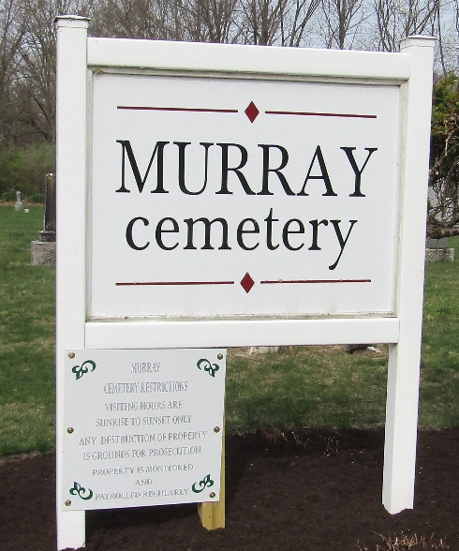

Benjamin Dishong from tree Finding Family Connections
Birth 1850-1852 Wells, Indiana, USA
Residence 1880 Wells, Indiana, USA
Death 26 Oct 1889
Father William Dishong (1803-1896)
Mother Elizabeth Kline (1815-1866)

