Lewis Franklin DeWitt
April 17, 1905 – August 12, 1905

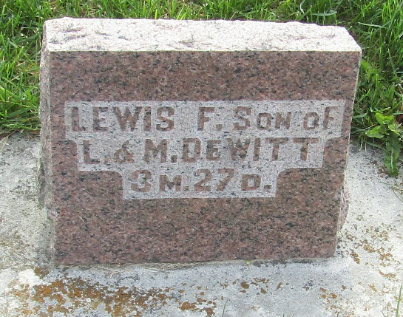

Lewis Franklin Dewitt
in the Indiana, U.S., Death Certificates, 1899-2017
Name Lewis Franklin Dewitt
Gender Male
Race White
Marital Status Single
Age 3/12
Birth Date 17 Apr 1905
Birth Place Indiana
Death Date 12 Aug 1905
Death Place Fort Wayne, Allen, Indiana, USA
Death Registration Date 1905
Father Lewis J Dewitt
Mother Addie M. Orden
Informant Lewis J. Dewitt
Burial August 14, 1905; Bluffton, Indiana

