Magdalena (Bender) Denton
July 1, 1827 – January 30, 1908

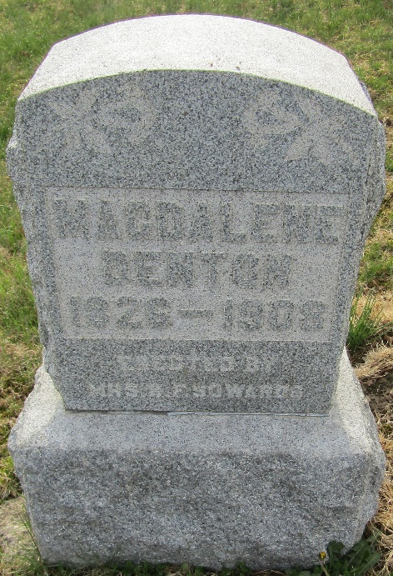

Magdalena Denton
in the Indiana, U.S., Death Certificates, 1899-2017
Name Magdalena Denton
Gender Female
Race White
Marital Status Widow
Age 81
Birth Date 1 Jul 1827
Birth Place Ohio
Death Date 30 Jan 1908
Death Place Tocsin, Wells, Indiana, USA
Death Registration Date 1908
Father Henry Bender
Mother ?? Slusher?
Spouse John Denton
Informant B? Sowards; Tocsin, Indiana
Burial February 1, 1908; Murray Cemetery

