Susan (Meyers) Denman
November 23, 1847 – July 27, 1915

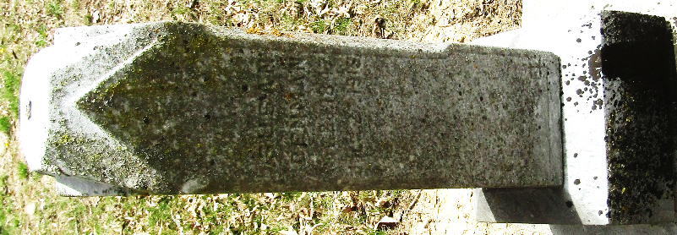

Susan Denman
in the Indiana, U.S., Death Certificates, 1899-2017
Name Susan Denman
[Susan Meyers]
Gender Female
Race White
Marital Status Widowed
Age 67
Birth Date 23 Nov 1847
Birth Place Lawerence Co. Pennsylvania
Death Date 27 Jul 1915
Death Place Bluffton, Wells, Indiana, USA
Death Registration Date 1910-1919
Father Jacob Meyers
Mother Dortha Painter
Spouse Samuel G. Denman
Informant Will Hixson; Bluffton, Indiana
Burial July 29, 1915; Murray Cemetery

