Samuel M. Denman
May 6, 1822 – August 28, 1888

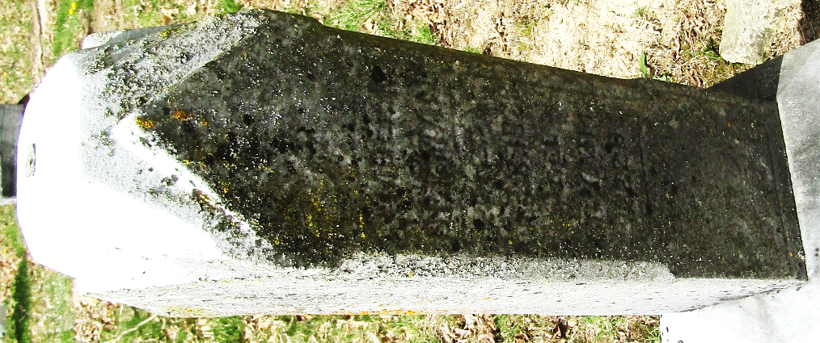

Samuel M Denman from tree Richards-Wilson Family Tree 2021
Birth 6 May 1822 Wayne, Monroe, Ohio, USA
Marriage 19 May 1868 Van Wert, Van Wert, Ohio, USA
Residence 1880 Wells, Indiana, USA
Death 28 Aug 1888
Father Mahlon J Denman (1799-1877)
Mother Catherine Tremaine (1804-1862)
Spouse Susanna Myers (1847-1915)

