David E. Denman
February 7, 1880 – March 9, 1880

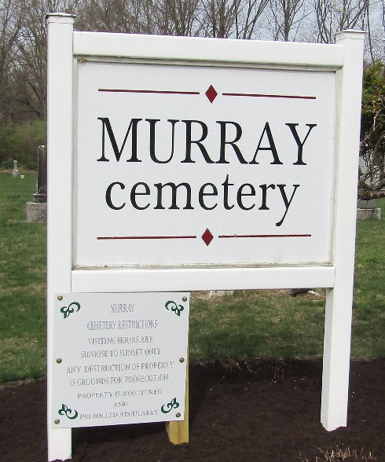

David E. Denman from tree George H. Hobson Tree
Birth 7 Feb 1880
Death 9 Mar 1880
Father Samuel Denman (1822-1888)
Mother Susan Myers (1847-1915)

