Martha Jane (Harvey) DeWitt
March 20, 1823 – February 9, 1890

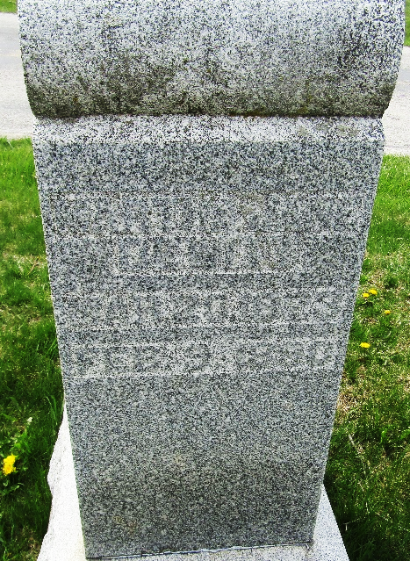

Martha Jane Harvey from tree Lampman Family Tree
Birth 20 Mar 1823 Union, Indiana, USA
Marriage 20 Mar 1856 Bluffton, Wells, Indiana, USA
Residence 1880 Wells, Indiana, USA
Death 9 Feb 1890 Bluffton, Wells, Indiana, USA
Father Robert Harvey (1788-1853)
Mother Elizabeth Richey (1794-1878)
Spouse Daniel Dewitt (1830-1885)
Spouse Jesse William Jeffries (1820-1848)

