William P. Davis
September 16, 1813 – March 29, 1893

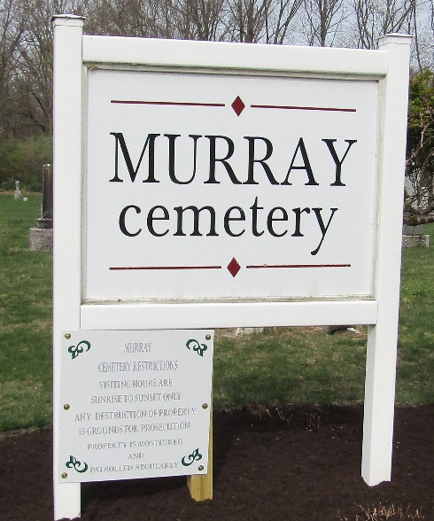

William P Davis from tree Theresa's Family Tree
Birth 16 Sep 1813 Greene, Tennessee, USA
Marriage 1 Jun 1835 Fulton, Indiana, USA
Residence 1880 Wells, Indiana, USA
Death 29 Mar 1893 Wells, Indiana, USA
Father George W Davis (1782-1865)
Mother Susan C Miller (Born 1792)
Spouse Lucinda Richey (1814-1901)

