Marcellus M. Davis
1854 – September 26, 1860

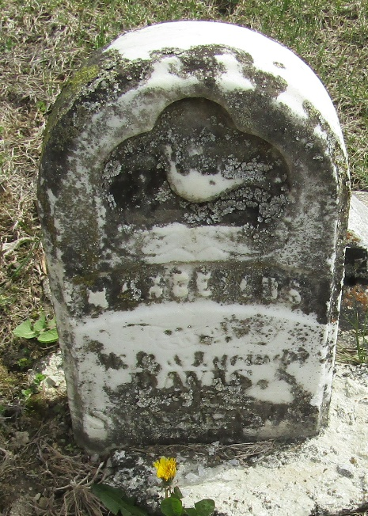

Marcellus M Davis from tree thomason Family Tree
Birth 1854 Indiana, USA
Residence 1860 Wells, Indiana, USA
Death 26 Sep 1860 Indiana, USA
Father William P. Davis (1813-1883)
Mother Lucinda Richey (1815-1901)

