Infant Davenport
August 16, 1907 – August 16, 1907

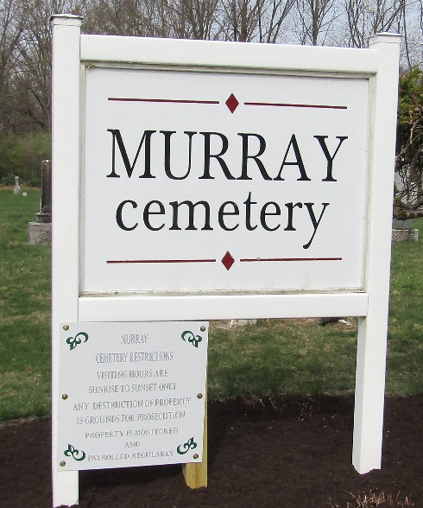

Davinport
in the Indiana, U.S., Death Certificates, 1899-2017

Name Davenport
Gender Female
Race White
Age 0
Marital Status Single
Birth Date 16 Aug 1907
Birth Place Wells County
Death Date 16 Aug 1907; stillborn
Death Place Lancaster, Wells, Indiana, USA
Death Registration Date 1907
Father George Davenport
Mother Ethel Biddle
Informant: Daniel Biddle; Bluffton, Indiana
Burial: August 17, 1907; Murray Cemetery

