William Edward Dalrymple
November 17, 1937 – November 17, 1937

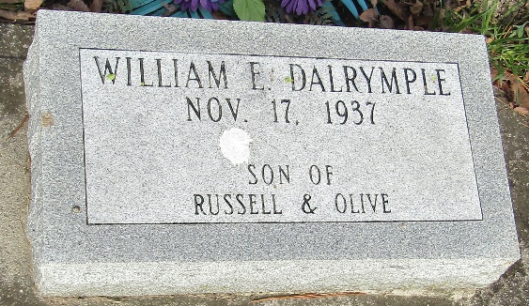

William Edward Dalrymple
in the Indiana, U.S., Death Certificates, 1899-2017
Name William Edward Dalrymple
Gender Male
Race White
Marital Status Single
Age 3 hours
Birth Date 17 Nov 1937
Birth Place Wells County, Indiana
Death Date 17 Nov 1937; birth injury
Death Place Bluffton, Wells, Indiana, USA
Death Registration Date 1937
Father Russel Dalrymple
Mother Olive Freeman
Informant Russel Dalrymple; Markle, Indiana
Burial November 18, 1937; Murray, Indiana

