Mary Ann Dailey
July 21, 1846 – September 22, 1864

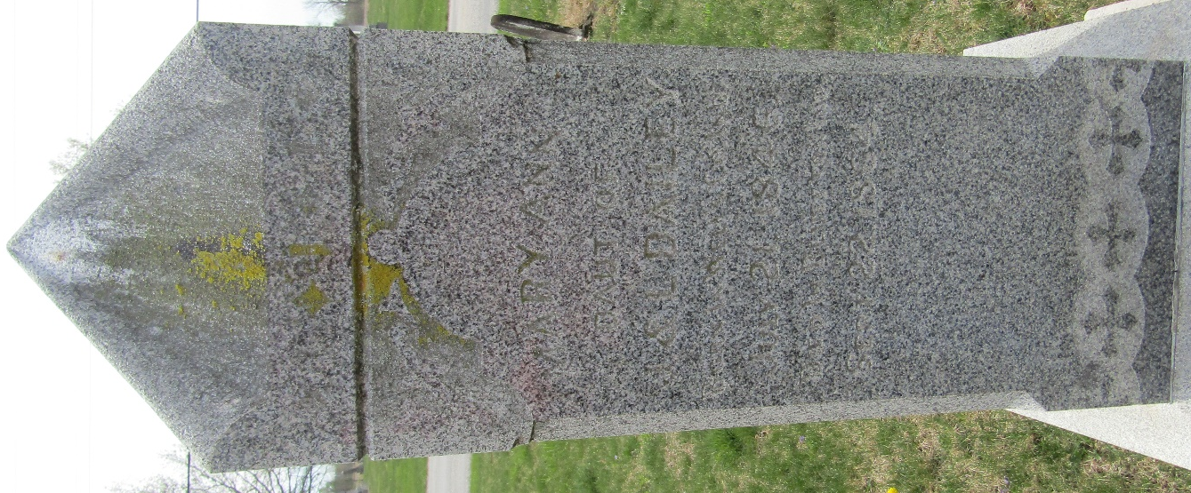

Mary Ann Dailey from tree Lee Alan Souder Family Tree Aug 2021
Birth 21 Jul 1846 Wells, Indiana, USA
Residence 1860 Bluffton, Wells, Indiana, USA
Death 22 Sep 1864 Wells, Indiana, USA
Father James Dailey (1815-1900)
Mother Lydia Garton (1820-1850)

