Lydia (Garton) Dailey
March 22, 1820 – February 13, 1850

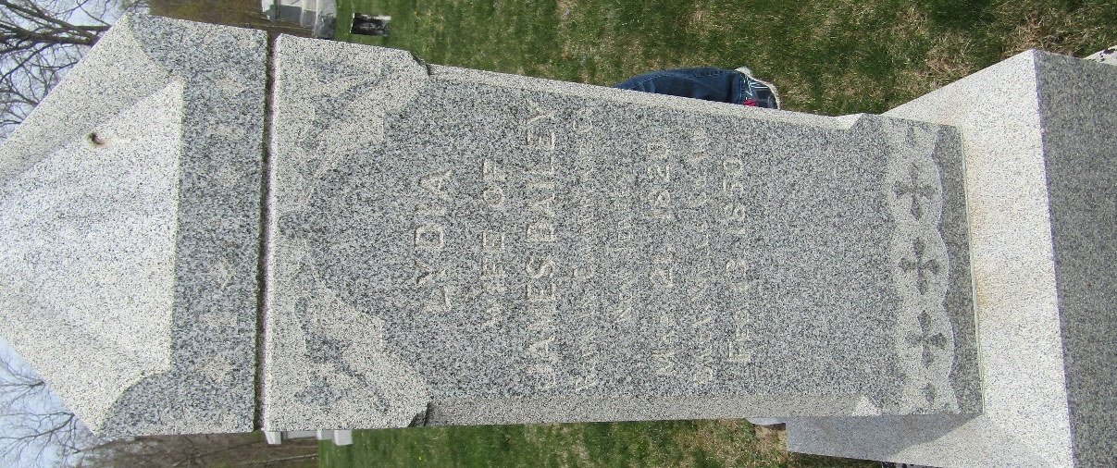

Lydia Garton from tree Lyons/Adams/Clark/Lechner Family Tree
Birth 22 Mar 1820 Cumberland, Cumberland, New Jersey, USA
Marriage 1 Nov 1837 Bridgeton, Cumberland, New Jersey, USA
Death 13 Feb 1850 Wells, Indiana, USA
Father Jonathan Garton (1796-1879)
Mother Elizabeth "Betsy" Souder (1796-1872)
Spouse JAMES DAILEY (1815-1900)

