Lewis Warrington Dailey
October 19, 1842 – March 2, 1862

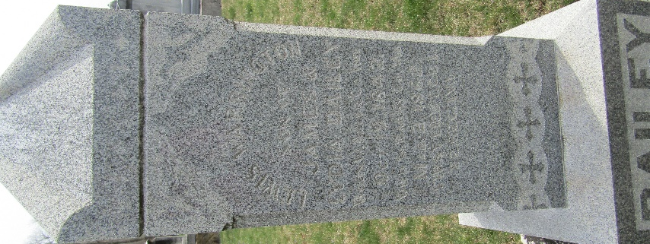

Lewis Warrington Dailey
in the U.S., Civil War Soldiers, 1861-1865

Name Lewis Warrington Dailey
Side Union
Regiment State/Origin Indiana
Regiment 22nd Regiment, Indiana Infantry
Company I
Rank In Sergeant
Rank Out First Lieutenant
Alternate Name Lewis Warrington/Daily
Film Number M540 roll 17
**
U.S., Civil War Pension Index: General Index to Pension Files, 1861-1934
Name Lewis W Dailey
Unit I 22 Ind. Infantry
Filing Place Indiana, USA
Relation to Head Soldier
Father James Dailey; filed Oct. 6, 1892

**
U.S., Civil War Soldier Records and Profiles, 1861-1865
Name Lewis W Dailey
Enlistment Date 15 Aug 1861
Enlistment Rank Sergeant
Muster Date 15 Aug 1861
Muster Place Indiana
Muster Company I
Muster Regiment 22nd Infantry
Muster Regiment Type Infantry
Muster Information Enlisted
Rank Change Date 23 Nov 1861
Rank Change Rank 1st Lieut
Muster Out Date 2 Mar 1862
Muster Out Place Cassville, Missouri
Muster Out Information died wounds
Side of War Union
Survived War? No
Was Officer? Yes
Injured in Line of Duty? Yes
Residence Place Bluffton, Indiana
Title Report of the Adjutant General of the State of Indiana

**
Lewis Warrington DAILEY from tree Lyons/Adams/Clark/Lechner Family Tree
Birth 19 Oct 1842 Allen, Indiana, USA
Residence 1861 Bluffton, Wells, Indiana, USA
Death 2 Mar 1862 Pea Ridge, Benton, Arkansas, USA
Father JAMES DAILEY (1815-1900)
Mother Lydia Garton (1820-1850)

