Infant Dailey
August 20, 1905 – August 21, 1905

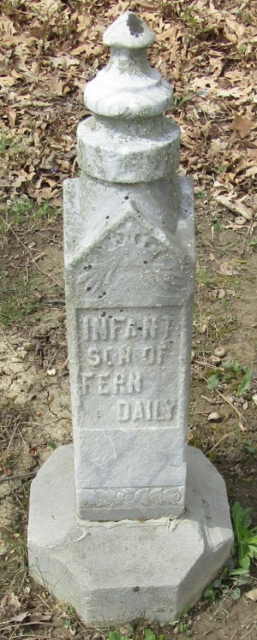

Infant Dailey
in the Indiana, U.S., Death Certificates, 1899-2017
Name Infant Dailey
Gender Male
Race White
Age 0
Birth Date 20 Aug 1905
Birth Place Bluffton, Indiana
Death Date 21 Aug 1905; premature
Death Place Bluffton, Wells, Indiana, USA
Death Registration Date 1905
Father Gibson
Mother Morg?? Daily
Informant Family
Burial August 21, 1905; Murray Cemetery

