Charles Stewart Dailey
October 30, 1841 – January 12, 1898

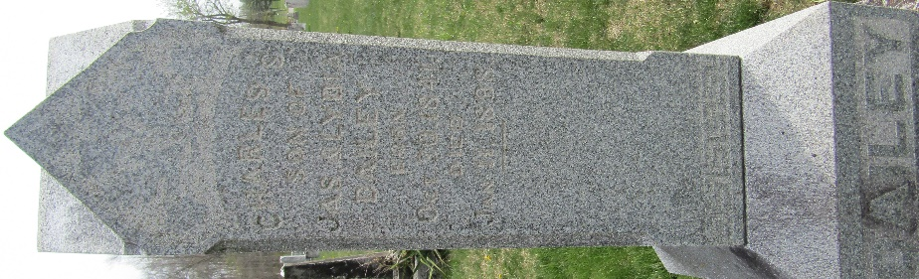

C. Dailey
in the Indiana, U.S., WPA Death Index, 1882-1920
Name C. Dailey
Date Jan 12, 1898
Location Wells County
Age 65 Yr
Gender Male
Race White
Source location County Health Office, Bluffton
Source notes The source of this record is the book H-14 on page 176 within the series produced by the Indiana Works Progress Administration.
**

Charles Stewart Dailey from tree The Plummer, Wasson, Sowards, Jones, Sweeny, Hall, Trullender, Roop Line
Birth 30 Oct 1841 Franklin, Johnson, Indiana, USA
Residence 1880 Wells, Indiana, USA
Death 12 Jan 1898 Wells, Indiana, USA
Father James Dailey (1815-1900)
Mother Lydia Garton (1820-1850)

