Vaughn Watson Crum
March 31, 1909 – September 16, 1909

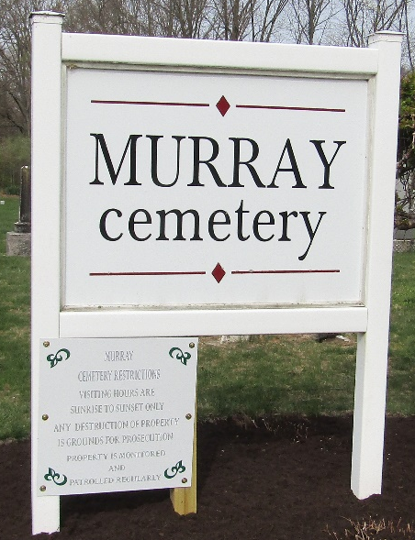

Vaughn Watson Crum
in the Indiana, U.S., Death Certificates, 1899-2017
Name Vaughn Watson Crum
Gender Male
Race White
Marital Status Single
Age 5 months, 17 days
Birth Date 31 Mar 1909
Birth Place Rockcreek Tp Wells County
Death Date 16 Sep 1909
Death Place Union, Wells, Indiana, USA
Death Registration Date 1909
Father Charles Crum
Mother Cressie Watson
Informant Charles Crum; Uniondale, Indiana
Burial September 18, 1909; Murray Cemetery

