Cressie M. (Watson) Crum
July 5, 1886 – April 1, 1909

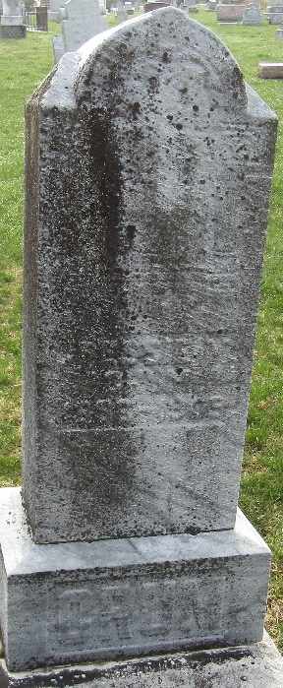

Gessie M Crum
in the Indiana, U.S., Death Certificates, 1899-2017

Name Cressie M Crum
[Gessie M Watson]
Gender Female
Race White
Marital Status Married
Age 22
Birth Date 5 Jul 1886
Birth Place Wells County
Death Date 1 Apr 1909; pregnancy related
Death Place Rock Creek, Wells, Indiana, USA
Death Registration Date 1909
Father William Watson
Mother E. J. Mabee
Spouse Chas Crum
Informant William Watson; Uniondale, Indiana
Burial April 4, 1909; Murray Cemetery

