Martha M. (Clowser) Croasdale
February 24, 1853 – October 1, 1875

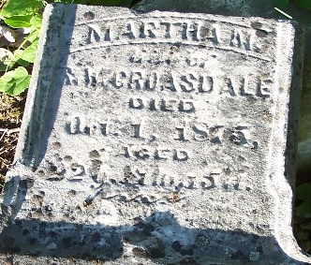

Martha M Clowser from tree Paul Families (& allied) of Northampton-Lehigh-Northumberland-Schuylkill, Pennsylvania
Birth 24 Feb 1853 Pickaway, Ohio, USA
Residence 1870 Wells, Indiana, USA
Marriage 1 Jan 1873 Wells, Indiana, USA
Death 1 Oct 1875 Wells, Indiana, USA
Father John Henry Clowser (1822-1880)
Mother Sarah Ann Schoch (1826-1904)
Spouse Robert W Croasdale (1849-1892)
* Other death listed:
Death 24 Apr 1875 Indiana, USA

