Harold Crist
September 6, 1917 - 1917

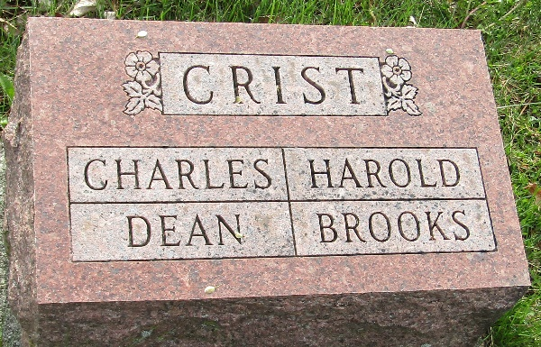

Harold Crist
in the Indiana, U.S., Birth Certificates, 1907-1944
Name Harold Crist; born alive; first born of twins
Gender Male
Birth Date 6 Sep 1917
Birth Place Lancaster, Wells, Indiana, USA
Father William C Crist; age 38
Mother Bessie G. Wilson; age 36; 7th child, all living
Certificate Number 64074
Roll number 45385_539584
Volume Range 1232 - 1237
**
Harold Crist from tree One Part of Your Family Tree
Birth 6 Sep 1917 Wells, Indiana, USA
Residence 1920 Wells, Indiana, USA
Death 1917 Wells, Indiana, USA
Father William Craig Crist (1879-1945)
Mother Bessie Gertrude WILSON Crist (1881-1962)

