Charles W. Crist
January 1, 1920 – September 19, 1920

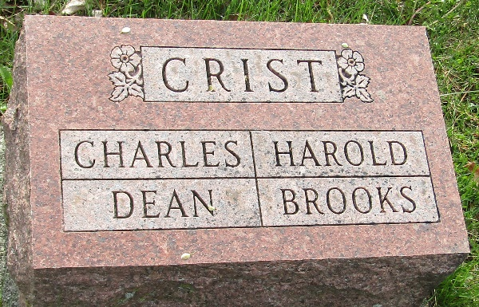

Charles Wendel Crist
in the Indiana, U.S., Birth Certificates, 1907-1944
Name Charles Wendel Crist
Gender Male
Birth Date 1 Jan 1920
Birth Place Lancaster, Wells, Indiana, USA
Father Wm Crist; age 40
Mother Bessie Wilson; age 39; 9th child; 8 living
Certificate Number 5624
Roll number 45385_539541
Volume Range 7 - 12

**
Indiana, U.S., Death Certificates, 1899-2017
Name Charles W. Crist
Gender Male
Race White
Marital Status Single
Age 8 months, 7 days
Birth Date 12 Jan 1920
Birth Place Indiana
Death Date 19 Sep 1920
Death Place Wells, Indiana, USA
Death Registration Date 1921
Father Wm Crist
Mother Bernice Wilson
Informant Wm. Crist; Bluffton, Indiana
Burial September 21, 1920; Murray Cemetery

