Brooks Eugene Crist
April 8, 1924 – June 16, 1924

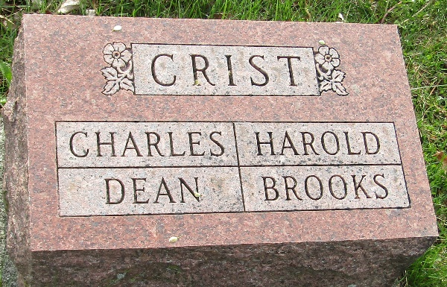

Brooks Eugene Crist
in the Indiana, U.S., Death Certificates, 1899-2017
Name Brooks Eugene Crist
Gender Male
Race White
Marital Status Single
Age 2 months, 14 days
Birth Date 8 Apr 1924
Birth Place Allen County, Indiana
Death Date 16 Jun 1924
Death Place Harrison, Wells, Indiana, USA
Death Registration Date 1924
Father Wm Crist
Mother Bessie Wilson
Informant Mr. and Mrs. Wm. Crist; Fort Wayne, Indiana
Burial June 17, 1924; Murray Cemetery

