Lenora J. (Millington) Cripe
July 27, 1874 – December 8, 1928

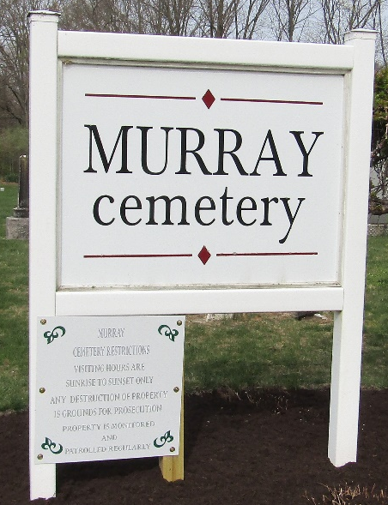

BLUFFTON – Mrs. Lenora J. Cripe, 54, died at her home here Saturday.
Surviving besides the husband are three brothers, Albert and Ezra Millington, Bluffton, and George of Burns, Ore.
Funeral services were held Monday from the Christian Union Church and burial was at Murray.

Muncie Evening Press; Muncie, Delaware County, Indiana
Monday, December 10, 1928

**
Indiana, U.S., Death Certificates, 1899-2017
Name Lenora J Cripe
[Lenora J Millington]
Gender Female
Race White
Marital Status Married
Age 54
Birth Date 27 Jul 1874
Birth Place Allen County, Indiana
Death Date 8 Dec 1928
Death Place Bluffton, Wells, Indiana, USA
Death Registration Date 1928
Father Philmon Millington
Mother Emma J. Worden
Spouse Edgar Cripe
Informant Edgar Cripe; Bluffton, Indiana
Burial December 10, 1928; Murray Cemetery

