Lena (Wand) McKinnon-Cripe
May 19, 1874 – July 14, 1929

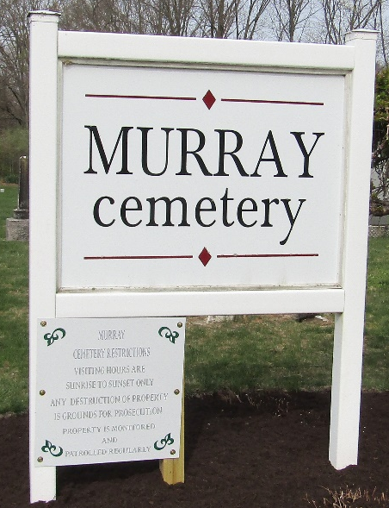

Lena Cripe
in the Indiana, U.S., Death Certificates, 1899-2017
Name Lena Cripe
[Lena Waud]
Gender Female
Race White
Marital Status Married
Age 55
Birth Date 19 May 1874
Birth Place Allen County, Indiana
Death Date 14 Jul 1929
Death Place Bluffton, Wells, Indiana, USA
Death Registration Date 1929
Father George Waud/Wand
Mother Jane Hall
Spouse Edgar Cripe
Informant Edgar Cripe; Bluffton, Indiana
Burial July 16, 1929; Murray Cemetery

**
Indiana, U.S., Marriages, 1810-2001
Name Lena Mckinnon [Lena Wand]
Gender Female; Race White
Age 55
Birth Date 19 May 1874; Birth Place Fort Wayne, Indiana
Marriage Date 15 Jun 1929; Marriage Place Indiana, United States
Residence Place Fort Wayne, Indiana
Father George Wand; Mother Jane Hall
Spouse Edgar Cripe
Page 182
FHL Film Number 002130179

