Daniel Earl Coleman
April 30, 1892 – August 20, 1925

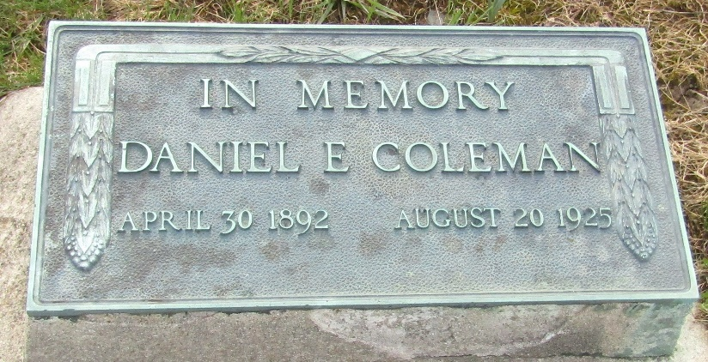

Daniel Earl "Charley" Coleman from Paap Family Tree
Spouse Mary Rosine Graft
Father Henderson Daniel "Hank" Coleman
Mother Rosetta Luvina Oliver
Children Robert Earl
Birth 30 Apr 1892 Hartford City, Blackford, Indiana, USA
Death 20 Aug 1925 Bluffton, Wells, Indiana, USA
Residence 1920 Bethlehem, Northampton, Pennsylvania, USA

