Sarah (Schoch) Clowser
April 24, 1826 – December 21, 1904

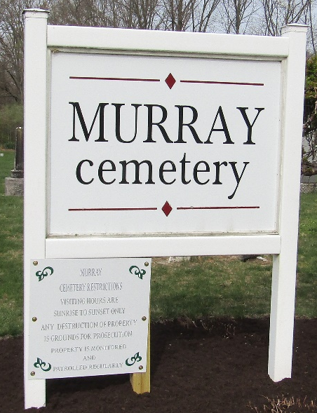

Sarah Clowser
in the Indiana, U.S., Death Certificates, 1899-2017
Name Sarah Clowser
[Sarah Shock]
Gender Female
Race White
Marital Status Widowed
Age 78
Birth Date 24 Apr 1826
Birth Place Pennsylvania
Death Date 21 Dec 1904
Death Place Craigville, Wells, Indiana, USA
Death Registration Date 1904
Father Daniel Shock
Mother Hans?
Spouse John H Clowser
Informant William Miller; Craigville, Indiana
Burial December 23, 1904; Murray Cemetery

