John Henry Clowser
December 29, 1822 – February 16, 1880

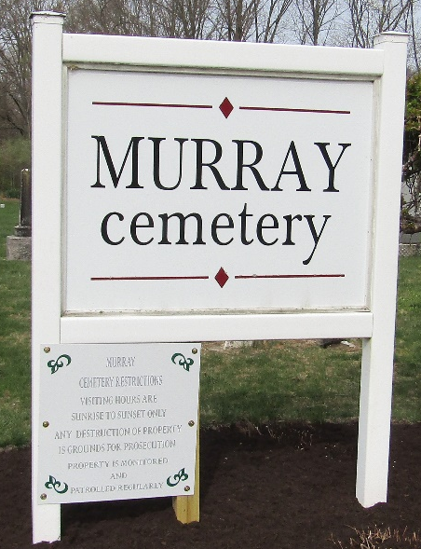

John Henry Clowser from tree Reed Family Tree
Birth 29 Dec 1822 Frederick, Virginia, USA
Marriage 25 Oct 1846 Pickaway, Pickaway, Ohio, USA
Residence 1870 Wells, Indiana, USA
Death 16 Feb 1880 Craigville, Wells, Indiana, USA
Father Henry Clowser (1797-1870)
Mother Regina Rosenberger (1803-1878)
Spouse Sarah Schoch (1826-1904)

