Jacob B. Clowser
September 15, 1860 – May 17, 1944

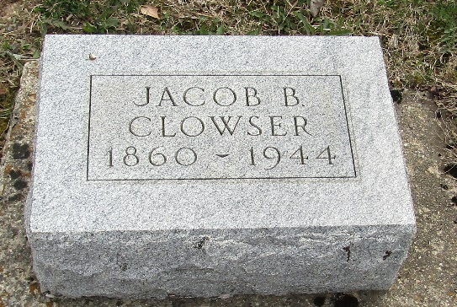

Jacob B Clowser
in the Indiana, U.S., Death Certificates, 1899-2017
Name Jacob B Clowser
Gender Male
Race White
Marital Status Single
Age 83
Birth Date 15 Sep 1860
Birth Place Edgar County, Illinois
Death Date 17 May 1944
Death Place Rural, Wells, Indiana, USA
Death Registration Date 1944
Father John H Clowser
Mother Sarah Schoch
Informant Joel W. Clowser; Bluffton, Indiana
Burial May 19, 1944; Murray Cemetery; Murray, Indiana

