Raymond Clark
July 18, 1904 – September 13, 1970

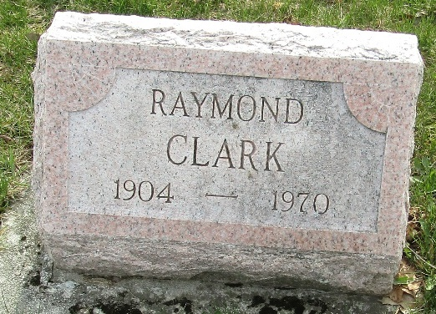

Raymond Clark
in the Indiana, U.S., Death Certificates, 1899-2017
Name Raymond Clark
Gender Male
Race White
Marital Status Divorced
Age 66
Birth Date 18 Jul 1904
Birth Place Indiana
Death Date 13 Sep 1970
Death Place Fort Wayne, Allen, Indiana, USA
Death Registration Date 1970
Father Jerry Clark
Mother Grace Lash
Informant Jerry Clark; nephew; Fremont, Indiana
Burial September 16, 1970; Murray Cemetery; Bluffton, Indiana

