Minnie Edith (Jackson) Clark
February 8, 1904 – July 10, 1960

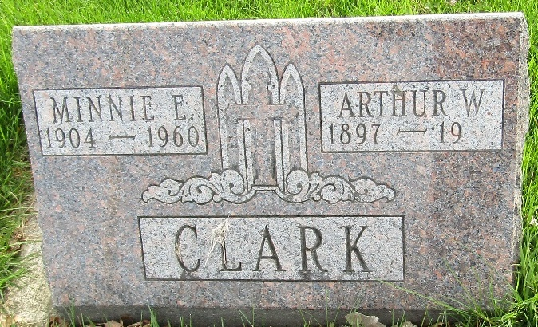

Minnie Edith Clark
in the Indiana, U.S., Death Certificates, 1899-2017
Name Minnie Edith Clark
[Minnie Edith Jackson]
Gender Female
Race White
Marital Status Married
Age 56
Birth Date 8 Feb 1904
Birth Place Indiana
Death Date 10 Jul 1960
Death Place Bluffton, Wells, Indiana, USA
Death Registration Date 1960
Father George Jackson
Mother Delcie Hunnicut
Informant Arthur W Clark; husband; Bluffton, Indiana
Burial July 12, 1960; Murray Cemetery; Wells County, Indiana

