John Allen Clark
January 12, 1825 – November 19, 1898

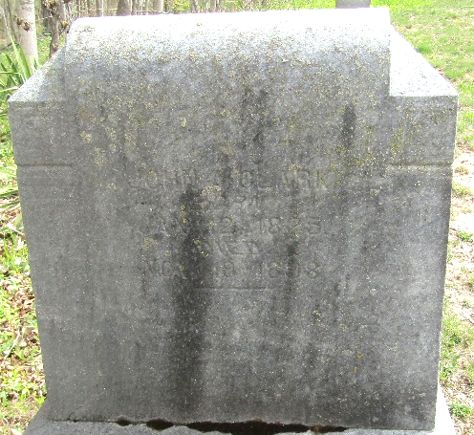

John Allen CLARK from tree 2015FTM(1)
Birth 12 Jan 1825 Ohio, USA
Marriage 1850
Residence 1880 Bluffton, Wells, Indiana, USA
Death 19 Nov 1898 Ossian, Wells, Indiana, USA
Father John Jonathan CLARK (Born 1778)
Spouse Charlotte FRYBACK (1830-1891)

