Jerry W. Clark
November 4, 1875 – February 2, 1909

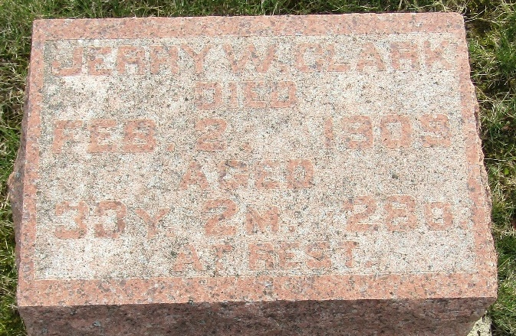

Jerry W Clark
in the Indiana, U.S., Death Certificates, 1899-2017
Name Jerry W Clark
Gender Male
Race White
Marital Status Married
Age 33
Birth Date 4 Nov 1875
Birth Place Indiana
Death Date 2 Feb 1909
Death Place Tocsin, Wells, Indiana, USA
Death Registration Date 1909
Father Jacob Clark
Mother Elizabeth Hobbs
Spouse Grace
Informant Jacob Clark; Bluffton, Indiana
Burial February 4, 1909; Murray Cemetery

