Harold L. Clark
January 28, 1933 – January 2, 1989

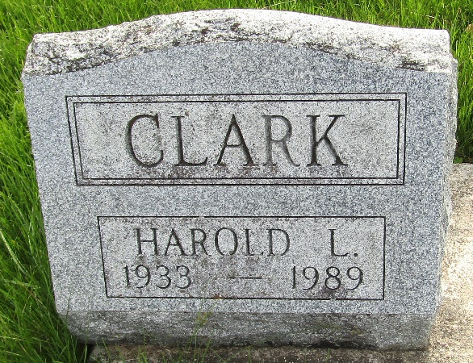

Harold L Clark
in the Indiana, U.S., Death Certificates, 1899-2017
Name Harold L Clark
Gender Male
Race White
Marital Status Divorced
Age 55
Birth Date 28 Jan 1933
Birth Place Bluffton, Indiana
Death Date 2 Jan 1989
Death Place Elkhart, Elkhart, Indiana, USA
Death Registration Date 1989
Father Arthur W Clark
Mother Minnie Jackson
Informant Susane Stoner; sister; Saline, Michigan
Burial January 5, 1989; Murray Cemetery; Bluffton, Indiana

