Grace Estelle (Lash) Clark
November 7, 1877 – November 7, 1926

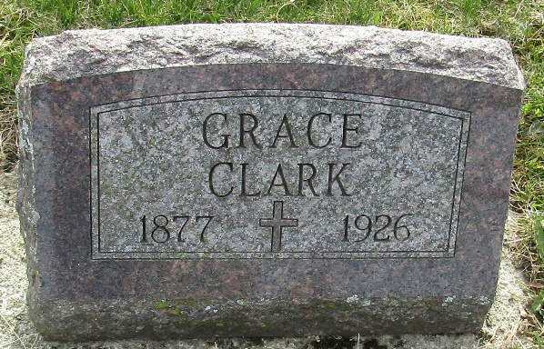

Grace Estelle Clark
in the Indiana, U.S., Death Certificates, 1899-2017
Name Grace Estelle Clark
[Grace Estelle Lash]
Gender Female
Race White
Marital Status Widow
Age 48
Birth Date 7 Nov 1877
Birth Place Wells County, Indiana
Death Date 7 Nov 1926
Death Place Bluffton, Wells, Indiana, USA
Death Registration Date 1926-1927
Father Andrew W Lash
Mother Sarah E Kleinknight
Spouse Jerry Clark
Informant Mrs. James High; Bluffton, Indiana
Burial November 8, 1926; Murray Cemetery

