Florinda (Marquis) Clark
December 27, 1816 – July 6, 1858

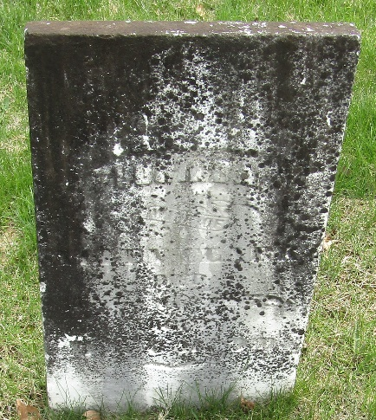

Florinda Marquis from tree Marquis Jahn Family_2023
Birth 27 Dec 1816 Beaver, Beaver, Pennsylvania, USA
Marriage 8 Jun 1837 Wayne, Monroe, Ohio, USA
Residence 1850 Wells, Indiana, USA
Death 6 Jul 1858 Wells, Indiana, USA
Father James Crawford Marquis (1785-1846)
Mother Sarah Kirkpatrick (1795-1849)
Spouse Allen Clark (1815-1888)

