Charlott (Fryback) Clark
October 12, 1830 – March 27, 1891

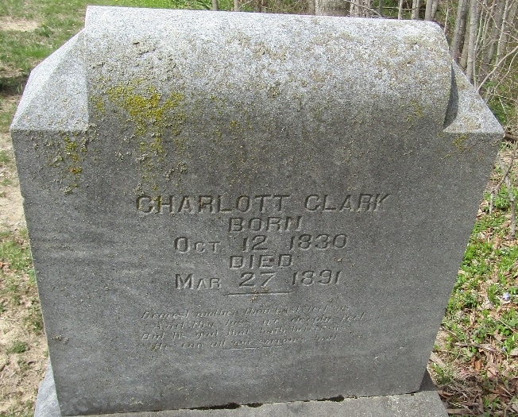

Charlotte Clark
in the Indiana, U.S., WPA Death Index, 1882-1920
Name Charlotte Clark
Date Mar 27, 1891
Location Wells County
Age 61 Yr
Gender Female
Race White
Source location County Health Office, Bluffton
Source notes The source of this record is the book H-14 on page 28 within the series produced by the Indiana Works Progress Administration.

**
Charlott Fryback from tree FamilyDG1
Birth 12 Oct 1830 Butler, Montgomery, Ohio, USA
Marriage 1849
Residence 1880 Bluffton, Wells, Indiana, USA
Death 27 Mar 1891 Wells, Indiana, USA
Father George Fryback (1790-1873)
Mother Susannah Deam (1791-1875)
Spouse John Allen Clark (1825-1898)

