Allen Clark
1815 – July 8, 1888

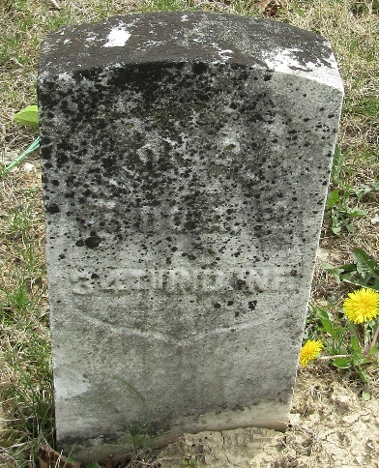

Allen Clark from Marquis Jahn Family_

Allen Clark
1815-1888
Birth ABT. 1815 • Pennsylvania, USA
Death 8 JUL 1888 • Apple Creek, Wayne, Ohio, USA
Parents Unknown
Spouse Florinda Marquis (1816-1858)

