Jane (Marshall) Campbell
November 21, 1794 – January 19, 1875

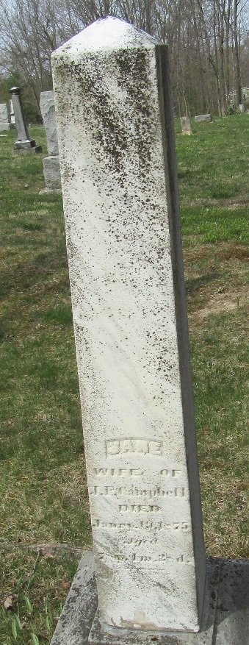

Jane Marshall from tree Ernie Fontes family tree
Birth 21 Nov 1794 Tyrone, Northern Ireland
Death 19 Jan 1875
Father Robert Marshall (1769-1853)
Mother Agniss (Agnes) Robinson (1769-1846)
4880 People 0 Records 8 Sources

