Isaiah Bush
January 12, 1854 – May 18, 1919

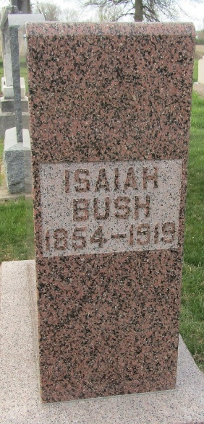

Isaah Bush
in the Indiana, U.S., Death Certificates, 1899-2017
Name Isaah Bush
Gender Male
Race White
Marital Status Married
Age 65
Birth Date 12 Jan/Jun?? 1854
Birth Place Indiana
Death Date 18 May 1919
Death Place Lancaster, Wells, Indiana, USA
Death Registration Date 1919
Father George Bush
Mother Mary Redding
Spouse Alice
Informant Mrs. Alice Bush; Ossian, Indiana
Burial May 20, 1919; Murray Cemetery

**
Isaiah Bush from tree Day/Gilbert Family Tree
Birth 12 Jan 1854 Rush, Indiana, USA
Marriage 1878 Wells, York, Maine, USA
Residence 1910 Wells, Indiana, USA
Death 18 May 1919 Bluffton, Clay, Georgia, USA
Father George Franklin Gregory Bush (1815-1899)
Mother Mary Ann Reddin (1820-1923)
Spouse Alice Anne Maddux (1858-1936)

