Alice Ann (Maddux) Bush
November 11, 1858 – April 24, 1936

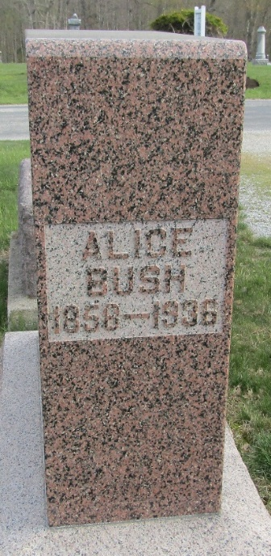

Alice Ann Bush
in the Indiana, U.S., Death Certificates, 1899-2017
Name Alice Ann Bush
[Alice Ann Maddux]
Gender Female
Race White
Marital Status Widow
Age 78
Birth Date 11 Nov 1858
Birth Place Indiana
Death Date 24 Apr 1936
Death Place Bluffton, Wells, Indiana, USA
Death Registration Date 1936
Father Jacob Maddux
Mother Anna Evans
Spouse Isaiah Bush
Informant Mrs. Paul Scott; Bluffton, Indiana
Burial April 26, 1936; Murray Cemetery

