William Henry Burnside
September 10, 1863 – April 4, 1933

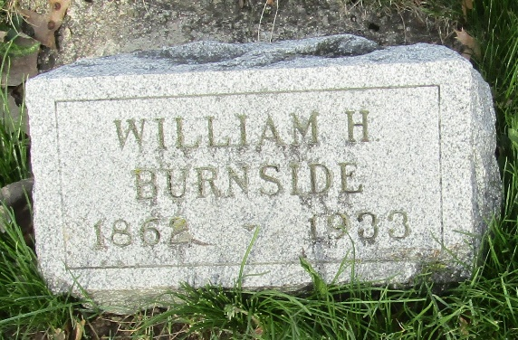

Bluffton - April 5 – Henry Burnside, 70, farmer whose home was two miles north of Murray, died at 1:30 o'clock this afternoon at the county hospital here of paralysis. He was stricken at his home Monday and fell to the floor. One of his hands struck a stove as he fell and was burned severely. He was brought to the hospital a few hours before he died.
Surviving are three daughters who live in Chicago. He lived alone on the farm and there are no immediate relatives in this vicinity.
No funeral arrangements had been made this evening.

Journal-Gazette, Allen County, Indiana
April 5, 1933

**
Indiana, U.S., Death Certificates, 1899-2017
Name Henry W. Burnside
Gender Male
Race White
Marital Status Divorced
Age 69
Birth Date 10 Sep 1863
Birth Place Wells County
[Hocking Co.,Ohio]
Death Date 4 Apr 1933
Death Place Bluffton, Wells, Indiana, USA
Death Registration Date 1933
Father Silas Burnside
Mother Rebecca Arnd
Spouse Sarah E Michaels
Informant Mrs. Minnie Gosser; Chicago, Illinois
Burial April 6, 1933; Murray Cemetery

