Harriet (Wolf) Burnside
November 11, 1860 – March 5, 1907

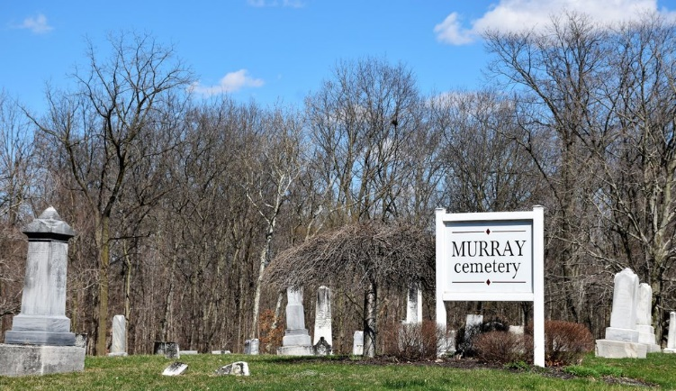
Photo by Colleen Sanders

Death at Uniondale
Mrs. Harriet Burnside, aged 46, wife of Henry Burnside, died at four o'clock this morning at her home at Uniondale, from cancer of the stomach, after five week's sickness.
The funeral will be held Thursday at ten o'clock at the Lutheran Church at Uniondale, with interment in Murray Cemetery.
The deceased was a sister-in-law of Mrs. Elias Poffenberger, of this city.

Bluffton Evening News, Wells County, Indiana
March 5, 1907

**
Harriet Burnsides
in the Indiana, U.S., Death Certificates, 1899-2017
Name Harriet Burnsides
[Harriet Wolfe]
Gender Female
Race White
Marital Status Married
Age 46
Birth Date 11 Nov 1860
Birth Place Indiana
Death Date 5 Mar 1907
Death Place Rock Creek, Wells, Indiana, USA
Death Registration Date 1907
Father Wm Wolfe
Mother Mary Baker
Spouse Henry Burnsides
Informant Henry Burnsides; Uniondale, Indiana
Burial March 7, 1907; Murray Cemetery

