Anna O. Burnett
June 28, 1904 – October 17, 1904

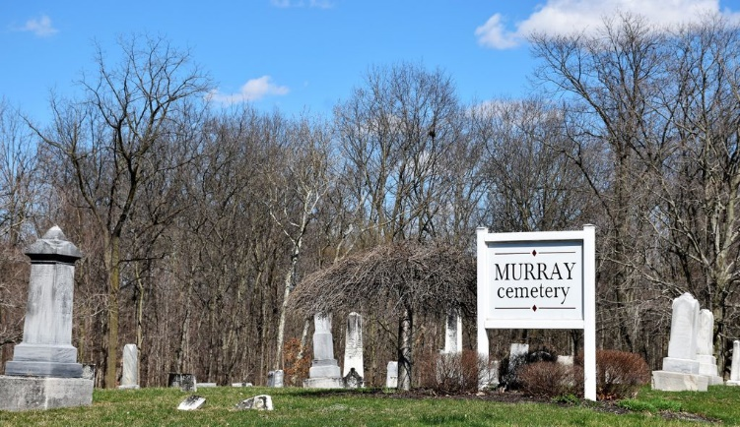
Photo by Colleen Sanders

Anna Brunett
in the Indiana, U.S., Death Certificates, 1899-2017
Name Anna Burnett
Gender Female
Race White
Age 3 months, 19 days
Birth Date 28 Jun 1904
Birth Place Indiana
Death Date 17 Oct 1904
Death Place Wells, Indiana, USA
Death Registration Date 1904
Father Wilson Burnett
Mother Crowl
Informant Mrs. Dislong?
Burial October 19, 1904; Murray Cemetery

