Henry S. Bulger
December 21, 1810 – March 12, 1873

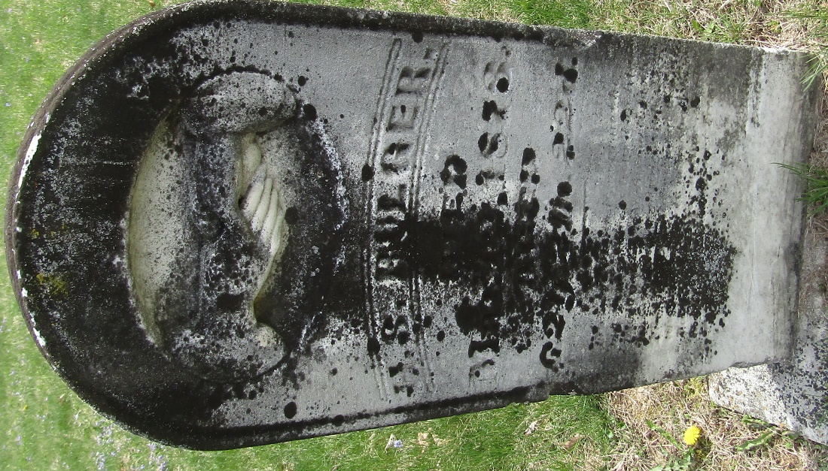

Henry S Bulger from tree thomason Family Tree
Birth 21 Dec 1810 Virginia, USA
Marriage 17 Apr 1854 Wells
Residence 1870 Wells, Indiana, USA
Death 12 Mar 1873
Father John Bulger (1783-1849)
Mother Catherine (Born 1791)
Spouse Nancy A. Scott (Born 1832)

