Lyda A. (Mabee) Brown
October 27, 1853 – May 15, 1883

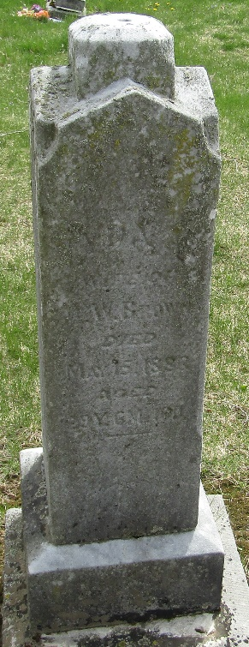

Lydia A. Lyda Mabee from tree Wilson Family Tree
Birth 27 Oct 1853 Ohio, USA
Marriage 7 Feb 1875 Wells, Indiana, USA
Residence 1880 Wells, Indiana, USA
Death 15 May 1883 Wells, Indiana, USA
Father David Mabee (1818-1864)
Mother Elisabeth Lesh (1819-1894)
Spouse William W Brown (1853-1932)

