Latisha Agles (Ogle) Brown
May 11, 1850 – April 5, 1913

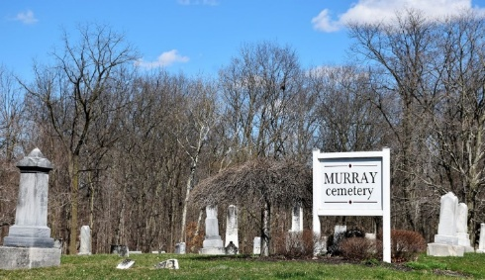
Photo by Colleen Sanders

FLOOD HASTENED DEATH OF MRS. BROWN
Murray Lady Was Ill When Flood Caused Removal From House

Mrs. John Brown, of Murray, passed away at her home Friday afternoon at three o’clock, after a prolonged illness with the dropsy. Her death was hastened somewhat by the floods. It was necessary to move her from the home to a place of safety when the water threatened to flood the house. She had been moved back home after the danger was over but the excitement had a bad effect on her.
Mrs. Brown’s maiden name was Latisha Ogle, and she was born in Noble County on Mary 11, 1851. She was married 45 years ago in Huntington county to John Brown. The following children survive with the bereaved husband: Benjamin Brown, Bluffton; Hamilton Brown, Ft. Wayne; Mrs. Oliver Derr, north of Bluffton; Mrs. Will Shuck, Winthrop, Wash.; Mrs. Elzey Patterson, Laurel, Ind.; Mrs. Benjamin Derr, north of Bluffton, and Glenn and Miss Cecil, at home.
Two half-sisters also survive, Mrs. Mary Brend, of Danville, Ill., and Mrs. Becky Powell, of Muncie.
The funeral will be held Monday at three o’clock at Murray. Burial at the Murray cemetery.

Unknown newspaper clipping
**

Mrs Lutisha Agles Brown
in the Indiana, U.S., Death Certificates, 1899-2017
Name Mrs Lutisha Ogles Brown
Gender Female
Race White
Marital Status Married
Age 62
Birth Date 11 May 1850
Birth Place Delaware County, Ohio
Death Date 5 April 1913
Death Place Murray, Wells, Indiana, USA
Death Registration Date 1913
Father [No Name]; Mother [No Name]
Spouse John Brown
Informant Oliver Durr; Bluffton, Indiana
Burial April 7, 1913; Murray Cemetery
**

Letitia (Latisha) Ogle from tree Teddi Schrakamp Family Tree
Birth 11 May 1851 Delaware, Indiana, USA
Marriage 8 Apr 1868 Huntington, Indiana, USA
Residence 1910 Wells, Indiana, USA
Death 5 Apr 1913 Wells, Indiana, USA
Father Canaan Ogle (1830-1874)
Mother Mary Jane Nelson (1830-1856)
Spouse John Brown

