John L. Brown
January 29, 1841 – April 8, 1914

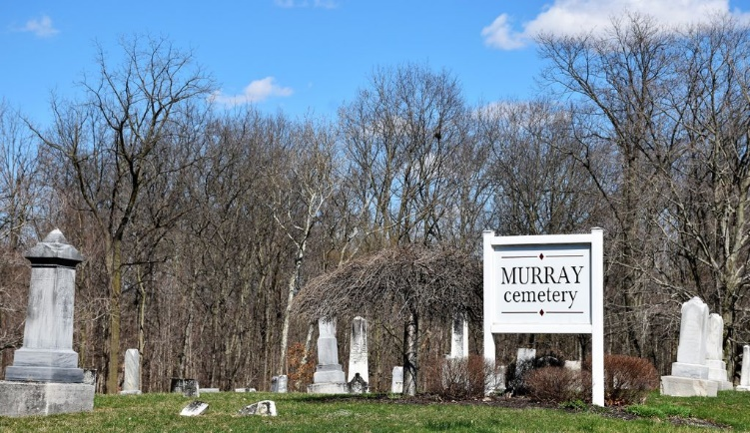
Photo by Colleen Sanders

John Brown
in the Indiana, U.S., Death Certificates, 1899-2017
Name John Brown
Gender Male
Race White
Marital Status Widow
Age 73
Birth Date None listed
Birth Place Indiana
Death Date 8 Apr 1914
Death Place National Military Home; Center, Grant, Indiana, USA
Death Registration Date 1914
Parents Not listed
Informant None listed
Burial April 10, 1914; Bluffton, Indiana
*

Indiana, U.S., Marriage Certificates, 1960-2012
Name John Brown
Gender Male
Marriage License Date 8 Apr 1868
Marriage Date 9 Apr 1868
Marriage Place Huntington, Indiana, USA
Spouse Lutitia Ogle
Officiator John J Auson
**
U.S., National Homes for Disabled Volunteer Soldiers, 1866-1938
Name John Brown
[Benjamin D Brown]
Admission Age 73
Birth Date abt 1841
Birth Place Huntington County, Indiana
Enlistment Date 10 Oct 1861
Enlistment Place Huntington , Indiana
Discharge Date 3 Feb 1866
Discharge Place Brownsville, Texas
Military Company G
Military Regiment 34'' Ind. Inf
Admission Date 1914
Residence Date 1914
Residence Place Marion, Grant, Indiana, USA
Death Date 8 Apr 1914
Relative Benjamin Brown; son; Bluffton, Indiana
**
John L Brown from tree 1 - Isle of Man, England, Ireland, Pennsylvania, Ohio Ancestor Links
Birth 29 Jan 1841 Huntington, Indiana, USA
Marriage 9 Apr 1868 Huntington, Huntington, Indiana, USA
Residence 1880 Wells, Indiana, USA
Death 8 Apr 1914 Marion, Grant, Indiana, USA
Father Benjamin D Brown (1811-1884)
Mother Nancy Augusta Dailey (1810-1882)
Spouse Lutitia Ogles (1850-1913)

