Glenola M. (Beers) Brown
May 29, 1923 – October 15, 1969

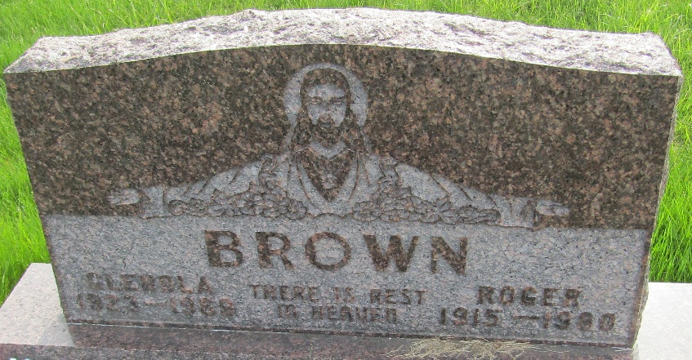

Mrs. Glenola Brown, 46, wife of Roger Brown, 116 South Union Street died Wednesday at Clinic Hospital. A native of Jackson, Michigan, she was married October 31, 1944 at Winchester to Roger Brown. She attended the Uniondale Wesleyan Methodist Church.
Also surviving are her mother, Mrs. Eddinger of Hillsdale, Michigan; a daughter, Mrs. William (Sylvia) Bennett of Bluffton; five sons, Roger, Dale, who is stationed in Vietnam and David G., stationed in Korea, both of whom are en route home, William J., Stanley T. and Robert B., all at home; Three sisters, Mrs. Viola Thomas of California, and Mrs. Dorothy Jordan and Miss Lori Eddinger, both of Jackson Michigan and six grandchildren.
Services will be Saturday at the Thoma Funeral Home with Rev. Eddie L. King officiating. Burial will be in the Murray Cemetery.

Wells County, Indiana Obituaries
October 15, 1969

**
Indiana, U.S., Death Certificates, 1899-2017
Name Glenola M Brown
[Glenola M Beers]
Gender Female
Race White
Marital Status Married
Age 46
Birth Date 29 May 1923
Birth Place Michigan
Death Date 15 Oct 1969
Death Place Bluffton, Wells, Indiana, USA
Death Registration Date 1969
Father Glen Beers
Mother Grace Whitney
Spouse Roger Brown
Informant None listed
Burial October 18, 1969; Murray Cemetery; Murray, Indiana

